**20/1/2020**

1:45pm meeting: Task for each teammate:

Sen: database

Yandong:Web Front

Irving:?

Issues:

1. Be familiar with Hugging face transformers;

<https://github.com/huggingface>

2. Install Python virtual environments on Ubuntu

3. Installing virtualevn

**21/1/2020 Fix issues**

https://www.digitalocean.com/community/tutorials/how-to-install-python-3-and-set-up-a-programming-environment-on-ubuntu-18-04-quickstart

1. Be familiar with Hugging face tranfers;

2. Install Python virtual environments on Ubuntu

1).check python2 version:python3 -V

2).install pip: sudo apt install -y python3-pip

3).check pip version : python3 -m pip –version

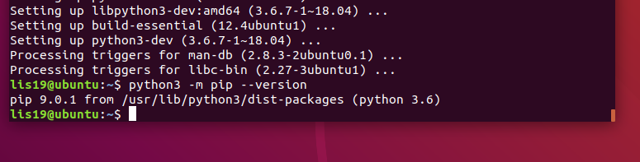

3. Install additional tool tom have a robust set-up for our programming environment:

sudo apt install build-essential libssl-dev libffi-dev python3-dev

4. Installing virtualevn

sudo apt install -y python3-venv

5. Create a Virtual Environment

python3.6 -m venv lis19_env

6. Activate Virtual Environment

source lis19_env/bin/activate

7. Test Virtual Environment

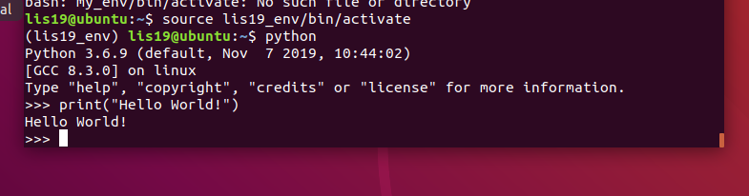

8. Deactivate Virtual Environment

Install Virtual Environment Successfully!

**1.Using ANACONDA to create project virtual environment**

1. Open Anaconda prompt
2. Create project environment
3. Choose “not installed” and search pytorch and tensorflow to install
4. Active project venv, type “pip install transformers”A screenshot of a computer screen

   Description automatically generated
5. Type “python” to go to virtual environment
6. Type “from transformers import pipeline”
7. Type “npl = pipelint(“question-answering”)
8. Enter npl questions and context to find answersA screenshot of a computer screen

   Description automatically generated

**2. Set up github repository**

Web framework: Flask + React

Database:? To decide what kind of database is the best one.

https://www.sisense.com/blog/postgres-vs-mongodb-for-storing-json-data/

PostgresSQL: able to handle SQL (and later NoSQL) data, but not JSON. If you have a purpose-build Database Management System(DBMS), which is designed as a native JSON(JavaScript Object Notation) database. 2. it’s a relational database that is much more concerned with standards compliance and extensibility than with giving you freedom over how you store data.

SQL(Structured Query Language)

MongoDB(DBMS): Dynamic schemas